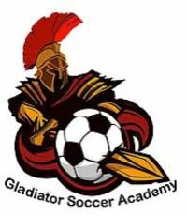
Reporting Child sexual Abuse and Misconduct

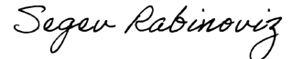
Sincerely,
Segev Rabinoviz
Owner, Gladiator Soccer Academy

